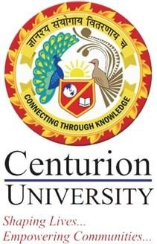

1.3.1 Institution integrates crosscutting issues relevant to Professional Ethics, Gender, Human Values, Environment and Sustainability into the Curriculum

Response:
Centurion University has made the courses on Gender, Human Rights and Ethics, and Environmental Science mandatory for all disciplines. Disaster Management and Climate Change have been integrated into the relevant curricula. Training on Safety and First Aid is also imparted to the students. Few of the programmes with cross cutting curricula are detailed below:
Centurion University is an equal opportunity organisation and treats students without gender bias. Girls are encouraged to take part in all kinds of sports, co-curricular activities, self-defence training and yoga.
Human Rights policies are in place for the protection of underprivileged and marginal groups.
The course on ‘Climate change and Sustainable Organisations’ is mandatory for all Management and BTech programmes.
Centurion University, with its goal for a clean environment, has declared the campuses ‘plastic free’, and fosters a culture of ‘love of nature’.
The University Community Diagnostic Center trains students to participate and assist in providing subsidised health care facilities (primarily tests) to the rural communities in its vicinity by organising regular eye camps and health camps.
The University has engagement with urban slums and incubated an Urban Micro Business Centre through which students work with the community to help them in establishing supply chains to the market for selling their products.

