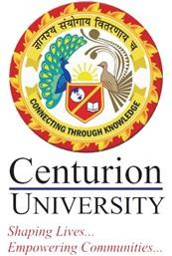

3.1.1: The institution’s Research facilities are frequently updated and there is a well-defined policy for promotion of research which is uploaded on the institutional website and implemented:
The Centurion University of Technology and Management (CUTM) is actively involved in research in the fields of science, engineering, technology, health sciences and humanities to enrich the present knowledge through lab-to-land and land-to-lab model. The objectives of research at CUTM are knowledge generation, evidence-based advocacy, experiential learning, strengthening the curriculum and sustainable product/patent development in line with SDGs.
At the department level, the quality assurance, progress evaluation and research outcome are assessed by the Departmental Research Committee. To promote high quality research aligned with the UN sustainable development goals (SDGs), the 21 Research Centres (RCs) are established in August 2020 following the ‘CUTM Research Promotion Policy of May 2017’. The university provides the research support through seed money grant to faculties and PhD research fellowship. To encourage faculty members for quality research output, CUTM designed and implemented research incentive policy in May 2019 followed by “Provost’s research award” which is implemented on September 2020 and subsequently upgraded in January 2022. These incentives acknowledge the publications, patents, products, start-ups, consultancy and extra mural projects. It is important to note that the research focus of RCs and faculties address almost all the SDGs of United Nations either directly or indirectly.

