A REPORT ON
INNOVATION IN TEACHING PEDAGOGY

TOPIC

HOW TO WRITE A GOOD RESEARCH PAPER

DAY – 5
Session 2
Time: 12am-1:30am

Resource Person:
Prof. Dr. Santap Sanhari Mishra, Professor, Dept. of Public Policy and Public Administration, Central University of Jammu

OBJECTIVE: Enlighten faculty members on How to write a good research paper

DESCRIPTION: On 24th June 2023, fifth day of the FDP, Prof. Dr. Santap Sanhari Mishra, Professor, Dept. of Public Policy and Public Administration, Central University of Jammu joined as a resource person for the session “How to write a good research paper". He explained how to write a clear and concise article statement that states the purpose and main argument of your research paper. Ensure that article is supported by evidence and can be effectively addressed throughout the paper.
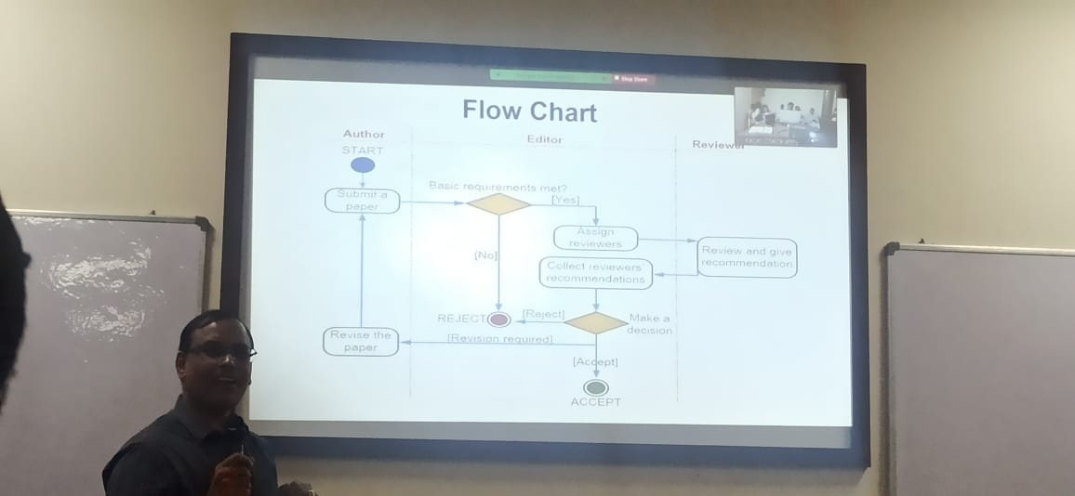

Organize our thoughts and structure your paper by creating an outline. Divide your paper into sections such as Introduction, Theoretical framework, Literature review & Hypotheses, Methods, Results and discussion, Implications, Conclusion, Acknowledgements, References and Limitations & Future research directions. This will provide a logical flow and help you stay focused.
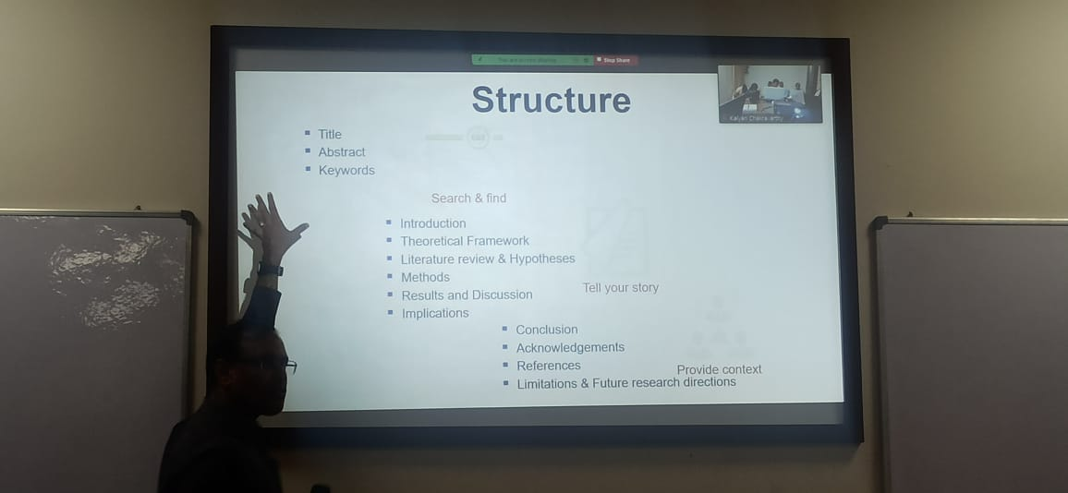

Grab the reader's attention with a strong opening that presents the topic and significance of our research. Clearly state our article and provide an overview of the paper's structure. Summarize and analyse relevant literature to provide context and support for our research. Identify existing gaps, controversies, or debates in the literature that your research aims to address. Describe the research methods and techniques employed in our study. Provide enough detail for others to replicate research, including information on data collection, sample size, data analysis, and ethical considerations.
Also, present findings in a clear and organized manner. Use tables, charts, graphs, or visual aids where appropriate to enhance understanding. Analyse the results and relate them back to our research question and objectives. Interpret our results and discuss their implications. Compare our findings with existing literature and address any discrepancies or limitations. Offer insights, propose explanations, and suggest areas for future research.
Resource person gave a clear idea regarding article publication and which types of tools should be use. He also clears many doubts of faculty members as well as research scholar.

OUTCOME: Faculty members were motivated for publication and get a clear idea regarding publications and statistical tools.

