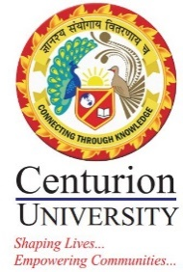
REPORT
TOPIC: Communication Skill & Interpersonal Relation
DATE: 28.01.2023
RESOURCE PERSON: Mrs. Tania Mishra

About the Resource Person: Mrs Tania Mishra presently doing my Research in area pertaining to Gender and Organization alongside also working as research associate, Dept of Sociology KIITS, BBSR. Having worked as Asst Prof in Management colleges and university since last 12 yrs, her journey into sociology started since 2 years. She had done my graduation from Ravenshaw university in Sociology and Masters in Sociology from University of Hyderabad. And did her management from IMIS Bhubaneswar. She is also am passionate about photography and Culture and hold a degree at Tunxis college ,USA.
She have a deep inclination towards work related to Communication , Society and Organization Culture. This is where she loved to get into an association with Centurion University , Management block. “It was a lovely experience in interaction with the students and conducting a workshop on Communications and interpersonal skill within organization,” was her feedback

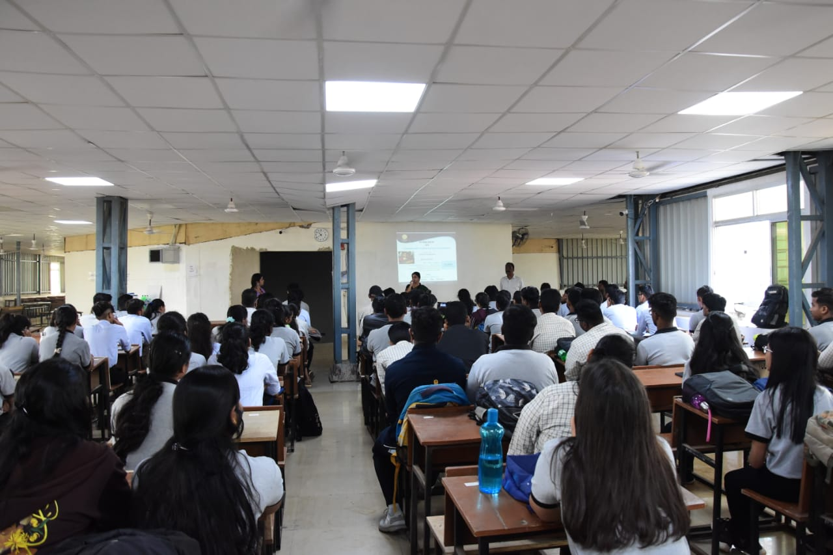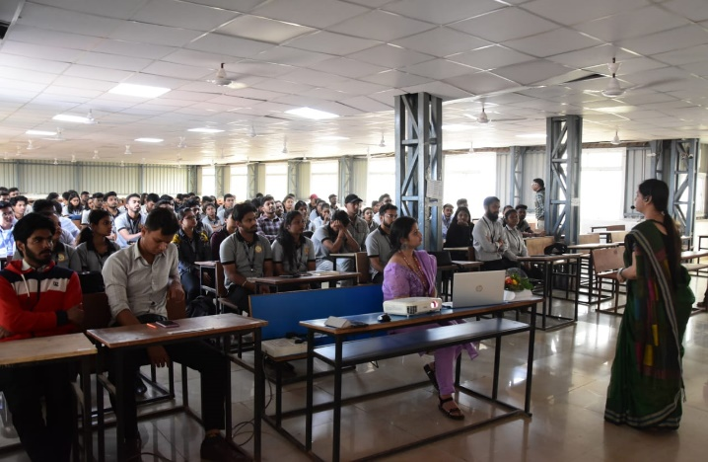

The session on interpersonal skills and communication in corporate today is a huge part of everyday life. The process of exchanging ideas, information, and feelings through messages and signals are extremely important part of communicating correctly. Phone calls, presentation, email, texting with all kinds of verbal and non-verbal aspects of interpersonal skills are an ongoing aspect of communication.
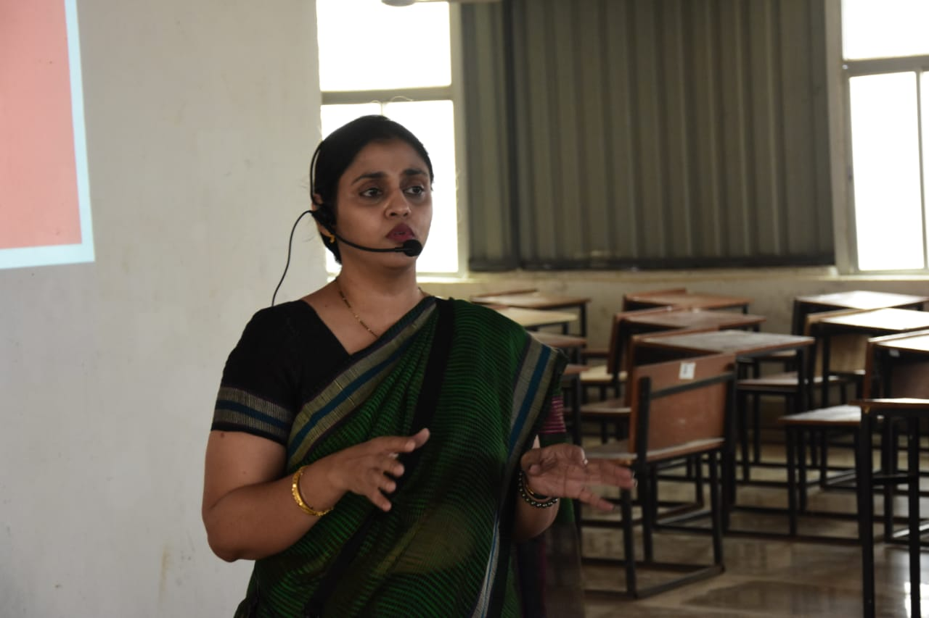

The session was to highlight and role play among student behaviour and mannerisms to understand their communication abilities and interplay of roles within organization. It was an interactive session and a learning experience to students for building a better managerial and leadership communicative performance.
