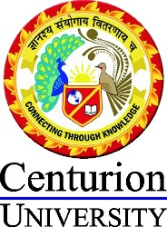

A REPORT ON MEDIA WEBINAR FOR THE DETAILED STUDY ON MOBILE JOURNALISM

Name of the Event: Webinar on Mobile Journalism
Date of the Event: 23 June 2022
Name of the Mentor: Mr Saban Kumar Maharana
No of Attendees: 14

For a thorough study of Mobile Journalism, the School of Media and Communication at Centurion University of Technology and Management, Bhubaneswar hosted a webinar on June 23, 2022. Mrs. Simple Sujata Mishra served as the instructor.

The webinar Speaker, "Simple Sujata Mishra," went over the concepts and significance of journalism in great detail. She began the discussion by going through the fundamentals of journalism and the significance of mobile journalism. She then continued with some insightful insights.

From 11 AM to 12 PM, the session lasted for almost an hour. By responding to queries from the class, she concluded the lesson.

